The Not So Myth of Social Media and Online Engagement

Eyad Hamam*

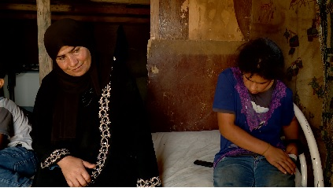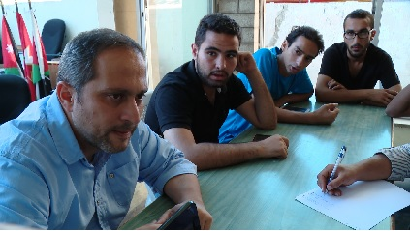

In the world of social development, art and artistic expression are tools that can convey information about the world we live in, challenge ideas, stir up debate, and move people in new directions. In countries like Jordan, where developmental projects by international bodies have a prominent role in civic and political life, a lot of development money is spent on trying to reach and engage audiences.

Before the Internet, the only way to do this was by physically taking the material to the audience or physically bringing the audience to the material, whether through concerts, exhibitions, film screenings, etc. When the Internet became mainstreamed, suddenly you had a potential audience of millions whom you could reach and engage with through the click of a button.

Today, Jordan has an Internet access/usage rate of almost 80%. Smartphones are used by more than 30% of the population and this number keeps growing as prices drop across the country. More than three million Jordanians use Facebook. It turns out, however, that getting people to watch your content is not as easy, and making them engage and interact with it even less so.

Aramram, the WebTV with whom I am a partner and work with, is one of several Jordanian sites trying to use the web and social media tools to create a new public space, where people from all over the country and across socio-economic segments can come together to debate issues that affect us all, whether political, economic, social, environmental, or ethical.

Our first really big success at generating online interaction was with May Taga Wa Fraata, a project whose goal was to create awareness around water and energy waste in Jordanian households. Aramram’s concept was to initiate an online competition based on environmental knowledge. The winners would have their homes audited for water and energy efficiency and then renovated to resolve as many issues as possible. Over the course of a year, more than 12,000 Jordanians participated in the competition, hundreds of thousands watched the episodes, and 17 homes from various socio-economic backgrounds were renovated across Jordan.

As the show progressed, we realized that we were creating real behavioral change among viewers, for as we started preparing for the second season of the show we found that many of the new winners had already implemented some of the tips and renovations that they had seen during the previous season.

This success made us realize that we really could reach and impact large numbers of people, but that we needed to systemize our approach so that we could measure what worked and what didn’t. So that is exactly what we tried to do for our next big projects, Malna’s and 209 King Hussein Street.

We built upon and improved our social media strategies and techniques. We hired a journalist whose only job was to monitor the online debate and engage the audience by answering comments with thoughtful and well-researched responses, mapping out and sharing the content with relevant websites and individuals. We even conducted follow-up interviews with specialists and experts in order to answer questions when necessary.

Once again, the results were incredible and the shows created intense online debate. Many posts reached thousands of comments and hundreds of shares. We received active participation by government officials, prominent online bloggers and activists, respected journalists and economic analysts, as well as a broad Jordanian audience spanning many socio-economic segments and geographies.

Wealth distribution is our most recent project. Supported by the Rosa Luxemburg Stiftung Palestine Regional Office it tackles topics related to fairness in education, labor unions and labor laws, working conditions, and the gap in social services. While the project was initially envisioned to be a film that would be screened and discussed at events around Jordan, we decided to shift the project to an online audience going a step further by trying to use the audience as a source of information.

We conducted online campaigns using various multimedia material, and instigated discussions around the selected themes, constantly questioning the audience and engaging with them to draw out their personal stories and experiences rather than their abstract opinions on issues.

The campaign was widely shared and it brought in thousands of comments and contributions. For example, the discussion around job conditions (a sample can be seen here) brought stories of long work hours, employment without contracts, employers who don’t pay social security or provide holidays. The discussion about the right to access higher education included stories from students with high grades who couldn’t get into their desired field because most of the available seats were allocated for people who could pay more. The right to have labor strikes brought stories of people who had union experience, and highlighted a law that banned strikes that was passed a few months earlier.

After sifting through hundreds of personal stories, we selected 6 cases and filmed with them to create illustrative personal profiles. We filmed with a union activist who initiated an independent union to demand his rights and those of his fellow workers, was fired from his job at the ministry as a result, but later re-instated after a 3 year legal battle (the video can be seen here); a school-girl from Zarqa who kept shifting from public to private schools depending on her parents’ financial situation; a dentist who organized a student movement that was able to halt university price hikes; a woman who lives in a tent with her 6 children even though she is supposed to receive housing benefits from the government. These profiles will be used in a longer documentary about social justice and wealth distribution that will be produced in 2016.

This kind of interaction with the audience is the essence of community media: a two-way conversation where the audience can give information as well as acquire it.

* Eyad Hamam has worked in the film production field in Jordan for the past 10 years. He is currently a producer and partner at www.aramram.com

Pictures:
1. Isa’af Bani Mustafa: a women and her children living in a tent in Amman though she’s entitled to housing benefits.
2. Dr. Fakher Da’as; Founder of Thabahtouna, a campaign for Fairness in University Education. The campaign managed to stall hikes in university fees and is now targeting more fair admission policies.

